Job Title
CASUAL YOUTH WORKER
Department  Youth Department | Team  YMCA Go
Reports to (Job Title)
Project Manager YMCA Go Project Lead

Responsible for 0 |  | Job Grade  £9.79 p/h
Location Contract Type
Stoke-On-Trent Casual, Funding until February
2024

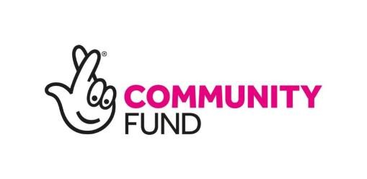
JOB DESCRIPTION

YMCA is a Christian organisation, committed to Equality and Diversity in the Work Place YMCA is committed to the safeguarding of children, young people and vulnerable adults.

Job Purpose (outcome)

YMCA North Staffordshire has been awarded a grant by the Lottery Community Fund to continue to offer, and develop open access youth sessions and to expand its reach to additional young people by delivering detached youth sessions in areas of Stoke-on-Trent which traditionally has less youth provision. The project will target 10-18 year olds (10-25 years old for those with disabilities or special educational needs). Sessions will include a range of activities that inspire and develop young people to positively engage. Much of the delivery work will be carried out in the evenings / weekends and during school holidays and will occasionally involve residential work.

The Youth Worker will report directly to the Programme Lead who will be responsible for delivering and leading activities to young people across city.

This is a fixed term contract until March 2024.

Duties and Responsibilities

PURPOSE OF JOB:

- To coordinate and deliver activities to young people across Stoke-on-Trent, 6 Areas Hanley, Abbey Hulton, Blurton, West End, Fegg Hayes, Kidsgrove
- To provide supervision, motivation and inspiration to young people
- Collect information on young people participating and forwarding information on to the administrator
- Ensure all safeguarding and critical incidents are reported within the correct time frame ensuring the safety and welfare of young people always.
- Maintaining effective relationship with local organisation and providers of Youth Provision
- Refer young people to relevant agencies where necessary e.g. YMCA Family Worker / Younger Minds / CSE
- Run social action projects with young people and support fundraising initiatives
- Work in partnership with professionals from other organisations that support young people such as social care, health, police, education, youth offending teams and local authorities;
- Attend regular training and development opportunities to maintain an up-to-date knowledge of safeguarding, health and safety and local policy developments;
- Work with parents and community groups to win support for improved provision and act as an advocate for young people's interests.
- To be fully versed with safeguarding to protect everyone from harm in accordance with current safeguarding legislation.
- Comply fully always with all the YMCA's policies and procedures relating to Safeguarding, Equality and Diversity, Professional Boundaries, Confidentiality & Data Protection and Health and Safety and to undertake training in these areas when required. Undertake such other duties as may reasonably be required.

Person Specification

Essential
Knowledge
• Knowledge of young people and what inspires them to get involved
Relevant Experience
• Working within the Community
Skills and Ability
- Good communication and networking skills
- Good organisational skills
- Sports coaching or leadership qualifications (sports specific role, none essential for Arts, Computing and General roles)
- Ability to work independently and time manage work loads
- Excellent team player, and able to share good practice with working colleagues
- Knowledge of various monitoring/recording of information requirements, and their importance.
- Ability to travel around the city
- Willing to work flexibly including evenings and weekends
Other Requirements
• Willing to undertake any training to aid personal development

Desirable
Knowledge
• A knowledge of the youth sector
Relevant Experience
- Previous work in the Youth sector
- Residential experience

Skills and Ability
- Innovating new projects
- Computers / Coding (for coding role)
- Art
- Any skills that can be developed into sessions and activities that are engaging for Young People will be considered
Other Requirements
• Undertake any training to aid personal development.

