JOB DESCRIPTION

Job Title
YOUTH WORKER Non-Term Time
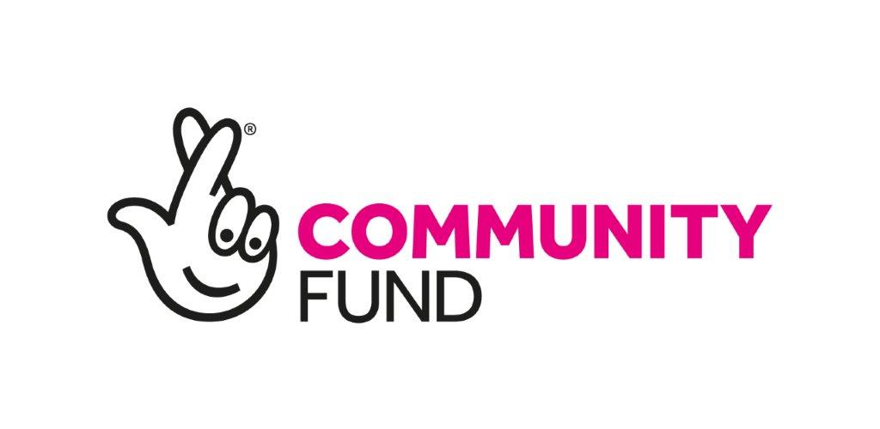
Department  Youth Department | Team  YMCA Go
Reports to (Job Title)
Project Manager YMCA Go Project Lead

Responsible for  0 |  | Job Grade  £13.10 p/h
Location  Stoke-On-Trent |  | Contract Type  School holidays Non-Term Time - Sessional

YMCA is a Christian organisation, committed to Equality and Diversity in the Workplace. The organisation is also committed to the safeguarding and promoting the welfare of children and young people and expects all staff and volunteers to share this commitment.

Job Purpose (outcome)

YMCA Go! Is a youth project that delivers fun and engaging youth provision across the city, funded by the Lottery Community Fund. Activities will cover a variety of trips across the city and counties. The programme is designed to inspire young people (aged 10-16 or 10-25 for those with disabilities or special educational needs) to positively engage with each other and their communities. Much of the delivery work will be carried out during school holidays (Non term time, including some evening and weekends depending on the trips.

The Youth Worker will report directly to the Programme Lead who will be responsible for delivering and leading activities to young people across city.

This is a fixed term contract for July and August 2025 it could be extended for other holidays or opportunities.

Duties and Responsibilities

PURPOSE OF JOB:

Activity Delivery

- Deliver engaging activities for young people during non-term time e.g. Fishing, Water inflatables, Blackpool pleasure beach and more.
- Support with driving a minibus (Staff over 21)

Youth Support
- Provide supervision, motivation, and inspiration to young people, fostering their personal and social development.
- Refer young people to appropriate support agencies, such as YMCA Family Coordinators, Younger Minds, or CSE services, when needed.

Safeguarding and Welfare
- Ensure safeguarding concerns and critical incidents are addressed through appropriate channels and within required periods, prioritising young people’s safety and welfare.
- Stay updated on safeguarding legislation and policies, attending regular training sessions.

Monitoring and Reporting
- Collect and report accurate data on youth participation, forwarding information to the project lead for monitoring and evaluation.
- Conduct risk assessments to ensure safe delivery of all activities.
- Complete case study templates, capture feedback and process this information in written and statistical reports.

Advocacy and Parental Engagement
- Engage with parents and community groups to gain support for youth activities and act as an advocate for young people’s interests.

Policy Compliance
- Follow all YMCA policies and procedures related to safeguarding, equality and diversity, confidentiality, and health and safety.

Other Duties
- Undertake additional responsibilities as required by management.

Person Specification

Essential
Knowledge
- Knowledge of young people and what inspires them to get involved
Relevant Experience
- Working within the Community
- Valid Full Driving licence (or soon to obtain) – ideally willing to learn to drive a minibus (age 21 and driving for over 1 year)
Skills and Ability
- Good communication and networking skills
- Good organisational skills
- Ability to work independently and time manage workloads.
- Excellent team player, and able to share good practice with working colleagues.
- Knowledge of various monitoring/recording of information requirements, and their importance.
- Ability to travel around the city.
- Willing to work flexibly including evenings and weekends and school holidays.
Other Requirements
- Willing to undertake any training to aid personal development

Desirable
Knowledge
- A knowledge of the youth sector
Relevant Experience
- Previous work in the Youth sector
- Residential experience

Skills and Ability
- Innovating new projects
- Adaptability
- Art/coding/sports coaching
- Any skills that can be developed into sessions and activities that are engaging for Young People will be considered.
- Full driving licence.
Other Requirements
- Undertake any training to aid personal development.

