JOB DESCRIPTION
Job Title
Leisure Assistant (Sports Activity Worker)
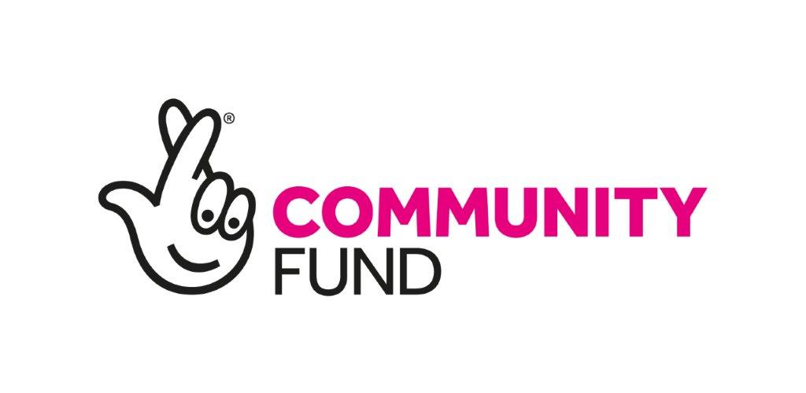
Department  Sports | Team  Sports
Reports to (Job Title)
Sports manager
Responsible for  0 |  | Job Grade
Location  Stoke-On-Trent |  | Contract Type  Casual

YMCA is a Christian organisation, committed to Equality and Diversity in the Work Place YMCA is committed to the safeguarding of children, young people and vulnerable adults.

Job Purpose (outcome)

Undertake cleaning, control of facilities and a range of duties in all areas in the Leisure Centre establishment. To provide support to customers and where necessary other staff engaged in a range of sports activities. To run activity sessions in the centre.

To actively engage with all YMCA customers, motivate people to improve their health & fitness and positively impact on lifestyles through the continued use of our facilities and services.

Duties and Responsibilities

PURPOSE OF JOB:
- Supervise gym & fitness areas and ensure service users comply with Centre rules and procedures and provide instruction to classes to ensure effective and safe health and fitness programmes
- Deliver the ‘member journey’ consistently to all customers and prospective members, including assisting sales staff in following leads from enquiry cards by calling, email or text message
- Actively walk the gym floor & facilities, interacting with members of all ages, offering programmes, advice on technique and other services available to members
- Identify and engage effectively with members of the community from all backgrounds, abilities and ages
- Operate the telephone system and accept telephone bookings to ensure efficient booking arrangements for leisure services and activities.

- Collect, record and secure money using the Management Information System and manual systems to ensure financial regulations are adhered to.

- Maintain records for a range of electronic and paper based systems to ensure effective record keeping and strict security and confidentiality of data.

- Check and maintain levels of stock for sale and equipment for hire and arrange for replacement supplies via the Manager.

- Liaise with staff on other shifts to ensure smooth changeovers and transfer of appropriate information for effective service delivery.

- Provide cover for other reception/clerical staff so that effective service delivery is maintained.

- Undertake filing, photocopying and other duties so that clerical arrangements are effectively delivered.

- Promote and practice customer care and contribute to improving standards, performance and efficiency by working to the standards and promote equality and health and safety standards.

- Clean internal and external areas and control facilities (including changing rooms and toilets) to ensure safe use by service users.

- Assemble and dismantle equipment (including sports, exhibition displays, social events etc) so that activities and events can take place in a safe and secure environment.

- Oversee general safety and behaviour of the public to prevent injury, misuse and damage to themselves, others, facilities and equipment.

- Handle and store supplies and equipment to ensure efficient operation of leisure facility.

- At time open and close the facility, checking security of the building.

- To participate in staff meetings and training

- Ensure all safeguarding and critical incidents are reported within the correct time frame

- Attend regular training and development opportunities to maintain an up-to-date knowledge of safeguarding, health and safety and local policy developments.

- Comply fully always with all the YMCA's policies and procedures relating to Safeguarding, Equality and Diversity, Professional Boundaries, Confidentiality & Data Protection and Health and Safety and to undertake training in these areas when required. Undertake such other duties as may reasonably be required.

Person Specification

Essential
Knowledge
- Knowledge of what inspires people
- Management information systems
- The rules and organisation of different sports
Relevant Experience
- Supervising sporting activities
- Set up various sports equipment
- Money handling
Skills and Ability
- Good communication, written and verbal
- Providing good customer care
- Cash handling
- Good organisational skills
- Ability to work independently and time manage work loads
- Excellent team player, and able to share good practice with working colleagues
- Knowledge of various monitoring/recording of information requirements, and their importance.
- Willing to work flexibly including evenings and weekends
- Be able to demonstrate awareness and understanding of special groups within the community including ethnic minorities and people with disabilities

Other Requirements
- Willing to undertake any training to aid personal development

Desirable
Knowledge
- A knowledge of the youth sector
Relevant Experience
- Previous work in the Youth sector
- Working within the Community

Skills and Ability
- First Aid qualification
- A sports or leisure qualification
- Sports coaching or leadership qualifications (sports specific role, none essential for Arts, Computing and General roles)

Other Requirements

