PRIVATE AND CONFIDENTIAL

FAMILY SUPPORT SERVICE
REQUEST FOR SUPPORT

This form must be completed in its entirety and
agreement to work with the service MUST be obtained from the family prior to being sent.
All incomplete forms will be returned to the referring agency which will result in delaying the referral process.

The information contained within this form will be shared with the family concerned in line with our Information Sharing Agreement

Completed forms need to be returned to:

District | Organisation | Contact Name | Address | Phone | Email
Cannock, Lichfield, South Staffordshire | Family Support by SCTSP | Sutinder Herian | Paycare House, George Street,  Wolverhampton  WV2 4DX | 01902 424147 | Sutinder.herian@sctsp.org.uk
Stafford (DSG only) | Family Support by SCTSP | Sutinder Herian | Paycare House, George Street,  Wolverhampton  WV2 4DX | 01902 424147 | Sutinder.herian@sctsp.org.uk
Stafford | YMCA North Staffordshire | Alison O’Donovan | Edinburgh House  Harding Road  Stoke-on-Trent  ST1 3AE | 01785 252141 | Stafford.referrals@ymcans.org.uk
Newcastle | Home-Start Newcastle Borough | Kate Hampton | Cornerstone, High Street, Knutton,  Newcastle-under-Lyme, ST5 6BX | 01782 938912 | info@hsnb.org.uk
Staffordshire Moorlands | Home-Start Staffordshire Moorlands | Louise Walker | School Yard, Earl Street, Leek, Staffordshire, ST13 6JT | 01538 387231 | Info@homestartsm.org.uk
Tamworth | Malachi Specialist Family Support Services | Laura Yates | Billesley Ark, 725 Yardley Wood Road, Birmingham, B13 0PT | 0121 441 4556 | tamworth@malachi.org.uk
East Staffordshire | East Staffordshire Family Support Service (Harvey Girls) | Kate Roberts | 73 Horninglow Road  Burton upon Trent  DE14 2PT | 01283 533449 | support@harveygirls.co.uk

NOTE TO REFERRER – PLEASE READ BEFORE COMPLETING THIS FORM
The Family Support Service is a Tier 2 service. This service is likely to be for families with multiple needs, although the child should only have a singular additional need as defined by the SSCB Threshold Document - Staffordshire's Threshold Framework - 'Accessing the Right Help at the Right Time' (Staffordshire only) – https://www.staffsscb.org.uk/Professionals/Procedures/Section-One/Section-One-Docs/Section-1E-SSCB-Threshold-document.pdf
Thank you for taking the time to complete the information required. We aim to respond to all referrals within 5 working days.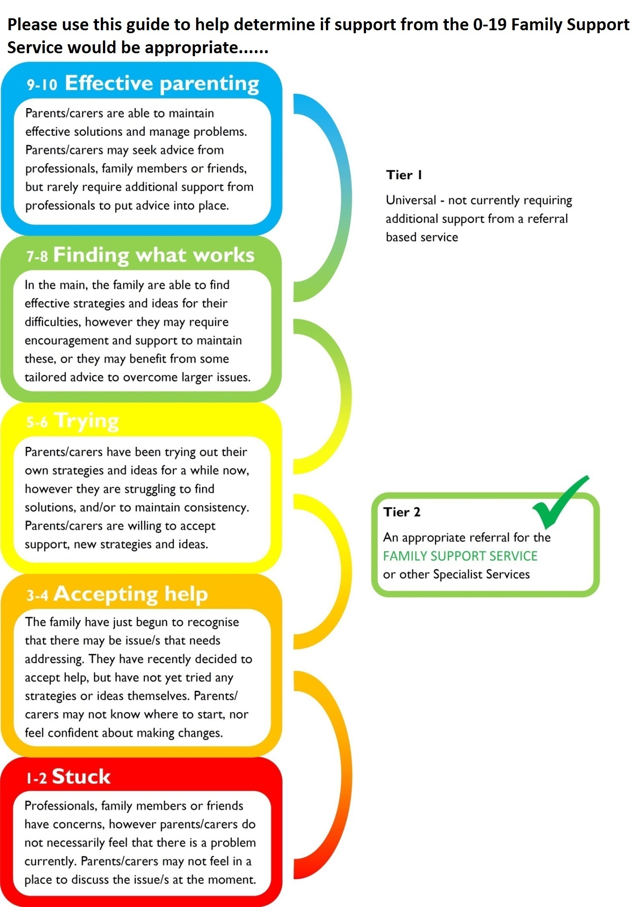

HOW MUCH SUPPORT DO THE FAMILY REQUIRE?
Please use the guide on the previous page to give each of the following areas a score between 1 to 10

PHYSICAL HEALTH
E.g. physical development, diet, healthy living, accessing healthcare, toilet training
1 2 3 4 5 6 7 8 9 10
☐ ☐ ☐ ☐ ☐ ☐ ☐ ☐ ☐ ☐

YOUR WELLBEING
E.g. parent/carers own wellbeing, peer support, mood, managing stress/difficulties, mental health
1 2 3 4 5 6 7 8 9 10
☐ ☐ ☐ ☐ ☐ ☐ ☐ ☐ ☐ ☐

MEETING EMOTIONAL NEEDS
E.g. child’s wellbeing, parent-child relationship, emotionally fuelled behaviour, understanding feelings
1 2 3 4 5 6 7 8 9 10
☐ ☐ ☐ ☐ ☐ ☐ ☐ ☐ ☐ ☐

KEEPING CHILDREN SAFE
E.g. safety in and out the home, child’s understanding of dangers, family history or current situation
1 2 3 4 5 6 7 8 9 10
☐ ☐ ☐ ☐ ☐ ☐ ☐ ☐ ☐ ☐

SOCIAL NETWORKS
E.g. support network from friends & family, isolation, new to area, access to groups/activities/services
1 2 3 4 5 6 7 8 9 10
☐ ☐ ☐ ☐ ☐ ☐ ☐ ☐ ☐ ☐

EDUCATION & LEARNING
E.g. nursery/school attendance, play & learning at home, child’s development, access to toys/equipment/experiences
1 2 3 4 5 6 7 8 9 10
☐ ☐ ☐ ☐ ☐ ☐ ☐ ☐ ☐ ☐

BOUNDARIES & BEHAVIOUR
E.g. behaviour management strategies, age appropriate rules/boundaries, praise, consistency, child’s behaviour
1 2 3 4 5 6 7 8 9 10
☐ ☐ ☐ ☐ ☐ ☐ ☐ ☐ ☐ ☐

FAMILY ROUTINE
E.g. appropriate daytime/bedtime routines, sleep patterns, one-on-one time with child, family time
1 2 3 4 5 6 7 8 9 10
☐ ☐ ☐ ☐ ☐ ☐ ☐ ☐ ☐ ☐

HOME AND MONEY
E.g. suitability of home environment, cleanliness, family budget, appropriate benefits, access to financial services
1 2 3 4 5 6 7 8 9 10
☐ ☐ ☐ ☐ ☐ ☐ ☐ ☐ ☐ ☐

PROGRESS TO WORK
E.g. employment status, goal-setting, education/training, barriers to employment (such as childcare)
1 2 3 4 5 6 7 8 9 10
☐ ☐ ☐ ☐ ☐ ☐ ☐ ☐ ☐ ☐

Mandatory information required:

Referrer’s Name (if self-referral: person completing the form) |  |  | Organisation Name (if self-referral: relationship to child/ren)
Address
Telephone Number/s |  |  |  | Email
Parent/ carers permission given | Yes  No | Please note that a referral cannot be accepted without agreement to work with the service from the parent / carer.
Verbal permission can be accepted where a referral is being made by Staffordshire County Council or by the Health Visiting Hubs (where the family have not been met but have agreed e.g. via telephone).  Please note the Referrer also needs to record verbal permission |  | Date verbal permission gained:
 |  | Name and relationship to child of person who gave the verbal permission:
Information Sharing
Permission to referral to the Family Support Service
This is additional to any existing Privacy Notice
https://www.staffordshire.gov.uk/Your-council-and-democracy/Request-and-access-information/Privacy-notice.aspx

Using your personal information for the delivery of this service
The information provided on this form will be processed by Staffordshire County Council in accordance with the General Data Protection Regulation and the Data Protection Act 2018

Personal information which you supply to the Family Support Service may be shared within Staffordshire County Council departments and our partners who are also involved in supplying a service directly to you. This is to ensure that you receive the best service available as it will improve communication between organisations.

These partners can include district and borough councils, health, schools, Fire and Rescue, voluntary sector and the Police.

We will not disclose your information to any partner who is not supplying a service to you or any other organisation unless required to do so by law If you have any concerns about the planned use of your information please speak to your key worker. For further information on how your information is used, how we maintain the security of your information and your rights to access information, please refer to the Privacy Notice provided to you by your Key Worker.

I/We have had the Family Support Service explained to us and we agree to the child/ren named on this referral form being referred to the Family Support Service.

I/We give permission to the Key Workers from the Family Support Service to contact other agencies for further information in relation to this referral.

I/We also agree that information held by the Family Support Service and obtained through the referral and assessment process may be shared with relevant agencies or organisations for the purpose of developing and implementing a support plan. Information may also be shared with outside agencies for the purpose of evaluating the effectiveness of the Family Support Service initiative both locally and nationally. The sharing of information will be carried out in accordance with the terms and procedures of the Family Support Service information sharing protocol.

Parent/Carer Print name:………………………………………………………………………..
(Person with parental responsibility)

Signature:…………………………………………………………… Date: …………………………………………

Mandatory information required:
Name/s of Child/ren (include full surnames and forenames) please include unborns with their expected delivery date (if known)
Date/s of Birth
(of Child/ren)
Gender of Child/ren
Ethnicity of Child/ren
Is the child(ren) a Young Carer  (delete as appropriate) | YES/NO | YES/NO |  | YES/NO |  | YES/NO
Education Setting (nursery/school/
college)
UPN or NHS number for child (if available)
Address (include house number, street and post code)
Parent Name 1 & DOB |  |  | Parent Name 2 & DOB
Relationship to Child/ren |  |  | Relationship to Child/ren
Address (if different than above) |  |  | Address (if different than above)
Telephone Number/s |  |  | Telephone Number/s
Name(s) of other adults at the address e.g. partners/ Grandparents |  |  | Relationship to child/ren
Reason(s) for referral (refer to the identified areas of the Outcome Star on page 3).

***Please add as much information as possible, as this helps make sure appropriate support is in place in response to this referral.***
What actions have already been taken by you in relation to these concerns and what has been the result?
Other agencies known to be involved with the family (e.g. Health Visitor)

Please outline any health and safety issues or any other information that you believe we need to consider when working with this family
(such as: domestic violence; mental health; substance misuse)
Referrer Signature
Date of Referral
Thank you for taking the time to complete the information required.
We aim to respond to all referrals within 5 working days.

 | For use by Family Support Provider:
Family Support Provider Organisation Name
Allocated Keyworker Name
Keyworker Email
Keyworker Telephone
Key Worker has met with the family who agree to further support: | Tick as appropriate: | Agreed  Declined | Date key worker met with family:

WITHDRAWAL OF PERMISSION OR EXERCISING A DATA SUBJECT RIGHT UNDER GDPR

If you decide that you no longer wish to work with the service please complete this section and return it to your keyworker at the address below:
Surname: |  |  | Surname:
First Name(s): |  |  | First Name(s):
Address: |  |  | Address:
Postcode: |  |  | Postcode:

 | Yes | No
I no longer wish to receive the service

RETURN ADDRESS (OFFICE BASE FOR TEAM):

